Different Styles of Training for Core Professionalism
Step 1: Overview Slides for Domain 4
Highlight the fact that the focus is on quality, not quantity. Review key requirements from manual.
Step 2: Spend time helping participants learn about the Domain rubric and the components within it.
Explore the option that will work best for your staff:
A.) Creative Presentations- Assign different groups (departments, grade levels, etc.) to a single component within Domain 4 to present to the entire staff in a creative way. This could be broken up over different faculties meetings or presented all at once. Teachers could review materials such as the rubric, manual, written descriptions in the book, the EdImpact videos, the samples in the “Implementing the Framework” book and choose how to create the best learning experience for their staff. Efforts with this project could become evidence towards 4d: Participating in the Professional Community.
(Modeled at EES EO PLC July 14th)
B.) Reading Jigsaw – Ask teachers to sit in groups of 6, then assign each teacher a section of reading for one component in Charlotte’s book “Enhancing Professional Practice: A Framework for Teaching”. Have the teachers share with their group the key ideas from the reading and then reading and generate potential examples of evidences sources specific to each school.
 | Key Ideas | How Teachers Demonstrate This Concept
4a Reflecting on Teaching
Pg. 92-93
4b Maintaining Accurate Records Pg. 94-96
4c Communicating with Families Pg. 96-99
4d Participating in Professional Community Pg. 99-102
4e Growing and Developing Professionally Pg. 102-105
4f Showing Professionalism Pg. 106-107

(Modeled at Introduction to the Framework Training)
C.) Build-A-Chart – Sort the descriptors, indicators and samples of evidence for each component.
 | Descriptor | Indicators | Sample Piece of Evidence
4a
4b
4c
4d
4e
4f
(Modeled at EES EO PLC July 14th)
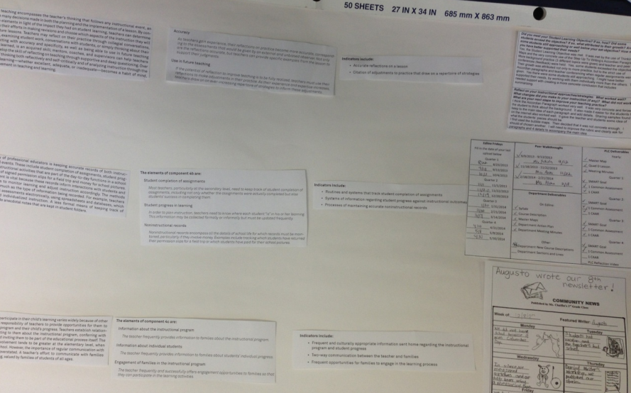
D.) Reflect Throughout the Year - Feature one component at different faculty meetings throughout the year with reflective questions at each. Use reflective questions from the “Implementing the Framework for Teaching in Enhancing Professional Practice” book (example pages 389, 392, 397, 400, 403, etc.).
Step #3. Ask teachers to complete a self-assessment.
(Penny from helpdesk is working on consolidating from thick book at element level)
Step #4. Plan
After the teacher understands what Domain 4 entails and has completed a self-assessment it is crucial to have a conversation with the administrator about the focus of growth and evidence collection for Domain 4. This does not have to be a separate conversation, but rather in can be woven in to other meeting times. As Charlotte Danielson said in her book Talk About Teaching: Leading Professional Conversations, “Of all the approaches available to educators to promotes teacher learning, the most powerful is that of professional conversations” (pg. 5). Once expectations for Domain 4 have been established, an area of focus could be incorporated into a teacher’s Professional Development Plan (format optional, unless the teacher is on a Principal Directed Professional Development Plan). Resources for the growth plan include the template available under the Professional Growth tab on PDe3 and pages 58-65 in Charlotte Danielson’s book “The Handbook for Enhancing Professional Practice”.

