STUDENT LEARNING OBJECTIVE TEACHER TEMPLATE

Teacher Name: |  | School: Middle |  | Complex:
Grade: | Content Area: Math |  | Course Name: |  | Period:

Student Population:
Total Number of Students __25___ Males __9__ Females__16__ SPED Inclusion _____ SPED Pullout _____ ELL __4__ GT _____ Other Groups _____________ _____ _____________ _____ ______________ _____

Additional Information:

Interval of instruction necessary to address goal: ___ yearlong _X_ semester ___ other (for quarter, track or trimester courses only)

SLO Components | For a complete description of SLO components and guiding questions, use the “Student Learning Objective Technical Guidance and Planning Document” supplement.
Learning Goal  What are the most important knowledge/skills I want my students to know and be able to do? | Learning Goal Statement:  Students will analyze and use proportional relationships to solve multi-step real-world problems by recognizing, representing, interpreting, applying processes and procedures and justifying their findings.  Aligned Standards/Benchmarks:  7.RP.A - Analyze proportional relationships and use them to solve real-world and mathematical problems.  CCSS.MATH.CONTENT.7.RP.A.2 Recognize and represent proportional relationships between quantities.  CCSS.MATH.CONTENT.7.RP.A.2.A Decide whether two quantities are in a proportional relationship.  CCSS.MATH.CONTENT.7.RP.A.2.B Identify the constant of proportionality (unit rate) in tables, graphs, equations, diagrams, and verbal descriptions of proportional relationships.  CCSS.MATH.CONTENT.7.RP.A.2.C Represent proportional relationships by equations. CCSS.MATH.CONTENT.7.RP.A.2.D Explain what a point (x, y) on the graph of a proportional relationship means in terms of the situation, with special attention to the points (0, 0) and (1, r) where r is the unit rate.  CCSS.MATH.CONTENT.7.RP.A.3  Use proportional relationships to solve multistep ratio and percent problems.  Rationale: School Year 2014-15 2 According to recent HSA – Bridge Assessment and quarterly benchmark assessment data, students in Grade 7 did not perform well on ratios and proportions. The Math department has decided to focus on ratios and proportions this year to help increase student achievement. Ratios and proportional relationships, along with arithmetic of rational numbers are the major work of 7th grade.  Depth of Knowledge level (circle one): 1 2 3 4
Assessments  How will I know if my students have met the learning goal? | Assessment Plan:  Assessment Plan:  Formative –Students will analyze a relationship between two quantities to determine whether or not a proportional relationship exists. (7.RP.A.2.A)  Formative – Students will identify unit rate (7.RP.A.2.B) for a given table.  Formative – Students will be asked to create an equation that represents a proportional relationship in a real life context. (7.RP.A.2.C)  Example Formative Task:  The students in Ms. Baca's art class were mixing yellow and blue paint. She told them that two mixtures will be the same shade of green if the blue and yellow paint are in the same ratio. The table below shows the different mixtures of paint that the students made.  A B C D E  Amount of Yellow Paint (cups) 0.5 1 1.5 2 3  Amount of Blue Paint (cups) 0.75 2 3 3 4.5  Which mixture(s) make the same shade as mixture A?  How many cups of yellow paint would a student add to one cup of blue paint to make a mixture that is the same shade as mixture A?  Write an equation that shows the relationship between the number of cups of yellow paint, y, and the number of cups of blue paint, b, in mixture E.  Formative- Students will write an explanation of what a point on a graph means in terms of a proportional relationship. Students will explain what the points (0,0) and (1,r) represent in the situation. (7.RP.A.2.D)  Example Formative Task:  Carlos bought 612 pounds of bananas for $5.20. Create a graph that would represent the price per pound if it were a proportional relationship.  Explain what the points (0,0) represents?  What is the price per pound of the bananas that Carlos bought? Is there a point on the graph that represents that amount? Explain.  What quantity of bananas would one dollar buy?  Which of the points in the coordinate plane shown below correspond to a quantity of bananas that cost the same price per pound as the bananas Carlos bought?  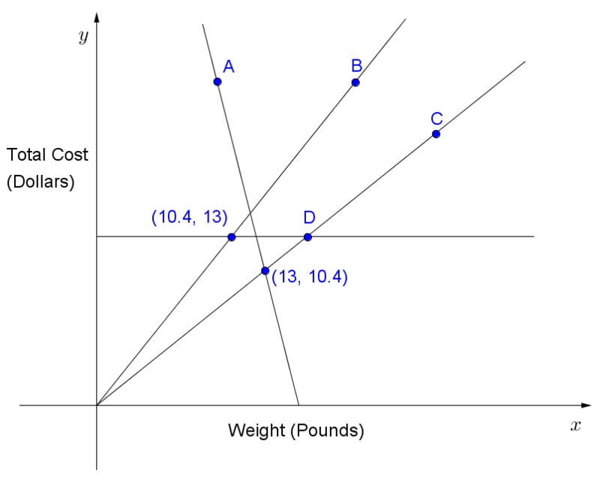  Summative – Students will use proportional relationships to solve multistep ratio problems. (7.RP.A.3)  Ex: An online magazine charges companies to place advertisements on their webpage. They divide each webpage into a grid and sell the regions labeled below:  The prices are constantly changing so they use the following ratios to calculate charges for the advertisers. The cost of region A compared to region B is 3:2, the cost of region A to region C is 3:1 and the cost of region A to region D is 4:1. If region A is currently selling for $600 a month, how much will advertisements in the other regions sell for?  How much more is an advertisement in region B compared to region D?  The online magazine company wants to run a sale next month. Suggest a new price for each region that is cheaper than the current prices while maintaining the proportional relationships. Justify your thinking for the suggested price of each region.  1 Well Below 2 Approaches 3 Meets 4 Exceeds  -Student does not successfully calculate the current prices any of the regions. -Student does not compare the prices in region B and D. -Little or no work is shown. -Calculation errors may be present along with a lack of problem solving skills. -No explanation or justification is provided. -Student does not suggest cheaper prices for next month that maintain a proportional relationship. -Student successfully calculates the current prices for at least one region (B, C, or D) -Student suggests prices for next month but the prices are either too high or do not maintain a proportional relationship in a majority of the regions. -Student suggests cheaper prices for next month that maintain a proportional relationship. -Little justification is provided. -Minor calculation errors. -Student successfully calculates the current prices for at least two of the three regions (B, C, D). -The comparison of prices between region B and D is clear and precise. -Student suggests cheaper prices for next month that maintain a proportional relationship in at least 3 of the regions. -Justification is clear and thorough. -Work is shown through the various steps of problem solving. -Student successfully calculates the current prices for all three regions (B, C, D) -Student suggests cheaper prices for all four regions next month that maintain a proportional relationship. -Justification is clear and may even include an equation to generalize the relationships. -Justification is clear and thorough. -Work is shown through the various steps of problem solving.  Summative average below 60% Summative average 60% -79% Summative average 80%- 89% Summative average 90%-100%  Formative assessments will be provided twice per quarter, with daily checks for understanding and weekly class quizzes. Summative assessments will be administered at the middle and end of the semester. Please see pacing guide and scheduled data team meetings for more information.  To determine if a student ultimately met proficiency of the learning goal a number of things will be taken into consideration.  • The formative assessments will be used as a factor in the overall proficiency of the learning goal. Students that did not do well on the first attempt of each formative assessment will be given another opportunity after interventions were provided.  • The summative assessments will weigh heavier than any given formative assessments because it measures the learning goal of being able to analyze proportional relationships and use them to solve multi-step real-world problems while providing justification.  • The summative assessments will be equally combined to determine overall proficiency.  The department agrees that in order for a student be in the exceeds proficiency level, he must have at least 90% of the assessments at the exceeds level. Proficient students must have 80% of the assessments at the proficient level. Approaching proficiency students must have at least 60% of the assessments at the proficient level. Students that have less than 60% of the assessments will be in the well-below proficiency level.
Expected Targets  What are my learning expectations for each student? | This section will be recorded in the record sheet.
Instructional Strategies  What strategies will I use to help all students meet the target? | Instructional strategies for various readiness level and content:  All Students:  - Will know and understand the learning targets for each lesson plan  - Instruction will scaffold from “I Do, We DO, and You DO” with a gradual release of responsibility being given to the student  - Check for understanding strategies will be utilized during lessons to gauge intermittent student understanding  - Collaborative work with graphing, equation matching and analysis  - Will be given mini lessons after direct instruction on challenges identified from formative assessments  - Frequent monitoring will be provided during instruction of new material  - Assignments will be differentiated on ability/capability of any given concept  Below Level Students  - Use manipulatives to reinforce concept  - Provide partially filled graphic organizers or guided notes  - Work in small groups or in 1:1 settings to reinforce concepts and/or skills  - Consider oral assessments  Above Level Students:  - Enrichment opportunities will be offered at the end of each formative assessment, so that teacher can focus on struggling learners while above students work on an enriching activity  - Assignments will be differentiated so that Challenge problems will be included for those students that are ready for them  ELL Students  - Preview of academic vocabulary  - Provide examples and visuals  - Peer support group

