Formatting an Individualized Rubric
NCTs may use the Working Portfolio Rubric Template available on the Intranet to copy and paste the five selected component rubrics from the original framework(s) into one streamlined document. This template, posted along with the rubrics, may be a convenient way to facilitate discussions about evidence alignment during the Beginning Conference and Ending Conference.

- Copy the component’s level of performance, critical attributes, and possible examples of evidence (easiest way is to click on the box located in the upper left corner and copying).
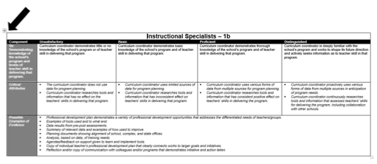
- Paste the copied information onto the Working Portfolio Rubric Template's blank pages.

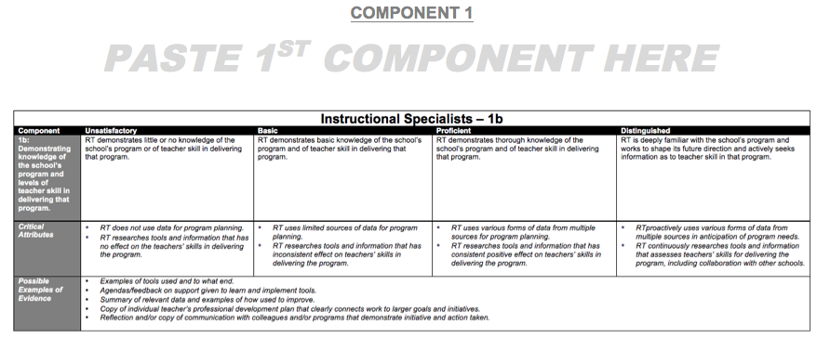

- Complete copying the information for all five components onto the Working Portfolio Rubric Template. Once completed, this template may be printed as a reference for both administrators and NCTs.

